# Example of Select Parallel execution

## Big table

BIG_TABLE is a random generated table with 100.000 rows.

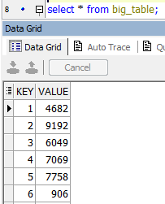

## Without paralleling (24 msec)

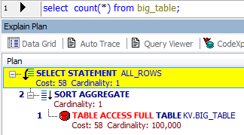

## 2 parallel processes (27msec)

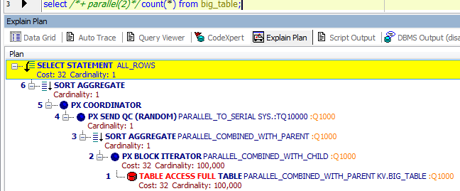

## 5 parallel processes (41 msec)

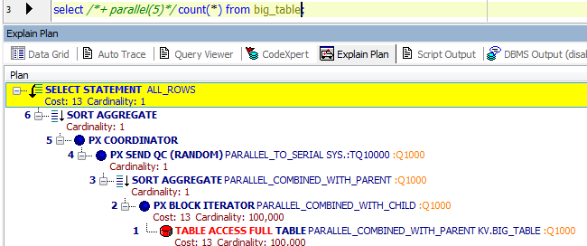

## 10 parallel processes (50msec)

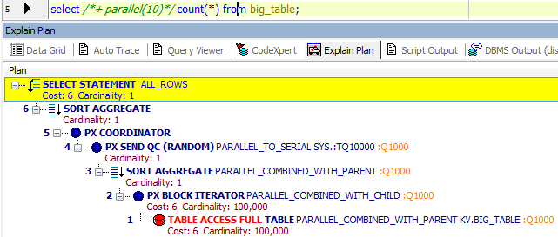

## 100 parallel processes (104 msec)

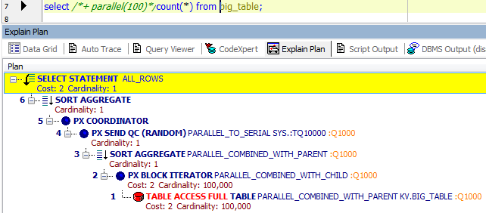

## Summarize tables

Table with 100.000 rows

|  |  |  |
| --- | --- | --- |
| Processes | Cost | Time, msec |
| 1 | 58 | 24 |
| 2 | 32 | 27 |
| 5 | 13 | 41 |
| 10 | 6 | 50 |
| 100 | 2 | 104 |

Table with 1.000.000 rows

|  |  |  |
| --- | --- | --- |
| Processes | Cost | Time, msec |
| 1 | 1229 | 36 |
| 2 | 682 | 62 |
| 5 | 280 | 142 |
| 10 | 136 | 178 |
| 100 | 14 | 648 |

# Example of Parallel DML

## Without parallelism (1 sec)

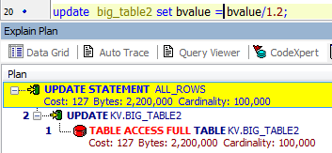

## 2 parallel processes (1 sec)

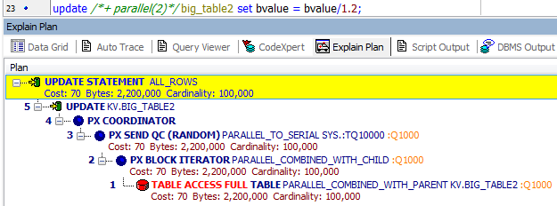

## 5 parallel processes (2 sec)

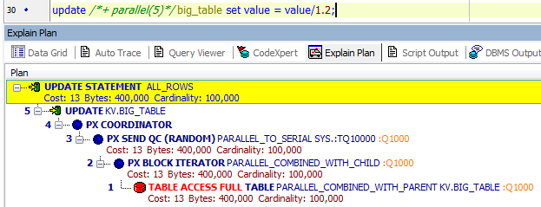

## 10 parallel processes(5 secs)

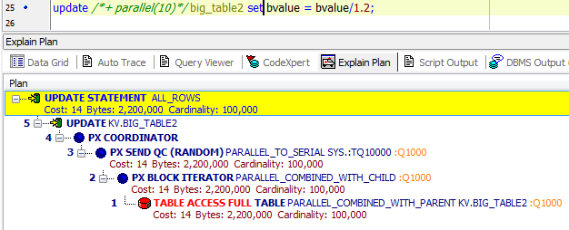

## 100 parallel processes (4 sec)

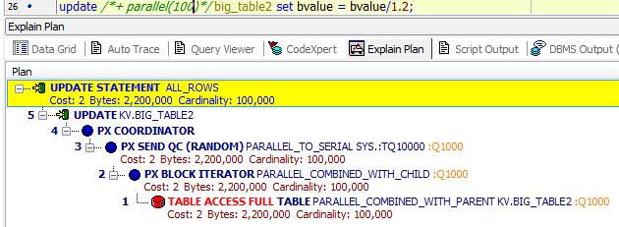

## Summarize table

|  |  |  |
| --- | --- | --- |
| Processes | Cost | Time, sec |
| 1 | 127 | 1 |
| 2 | 70 | 1 |
| 5 | 13 | 2 |
| 10 | 14 | 4 |
| 100 | 2 | 4 |

# CREATE Example of Parallel DDL

## Without manual-added parallelism (227 msec)

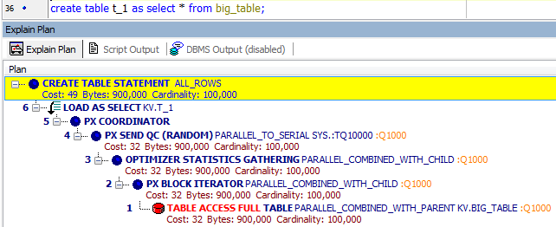

## Parallel degree 2 (172 msec)

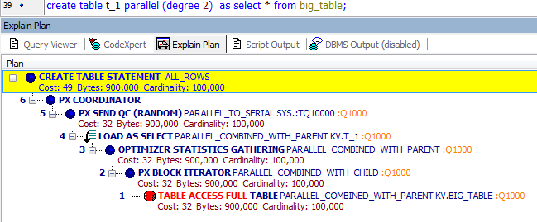

## Parallel degree 6 (355 msec)

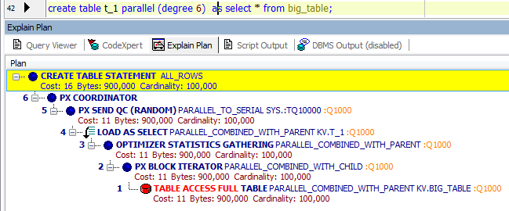

## Parallel degree 10 (719 msec)

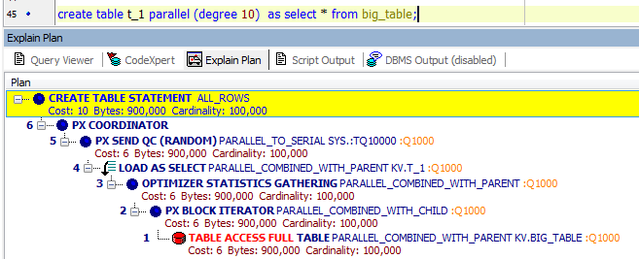

## Parallel degree 100 (1 sec)

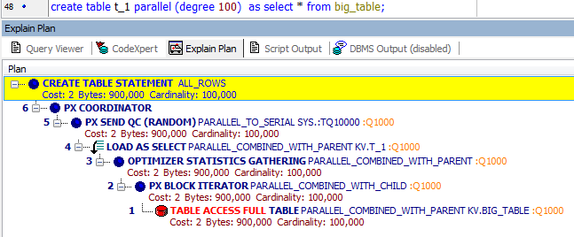

## Summarize table

|  |  |  |
| --- | --- | --- |
| Processes | Cost | Time, msec |
| 1 | 49 | 221 |
| 2 | 49 | 172 |
| 6 | 16 | 355 |
| 10 | 10 | 719 |
| 100 | 2 | 1000 |